
Land Information Ontario (LIO) Warehouse
Data Class Name: Tourism Establishment Area
Documentation
Produced by: Information Access and Information Management Policy Unit
Ministry of Natural Resources and Forestry
Date: July 27, 2015

Purpose

This document provides additional information to support the use of geospatial data. The Physical Model Diagram provides a visual representation of the relationships in the data class. The Data Change History lists all the modelling and access changes that have occurred during the lifecycle of the data class. A data description identifying table and field names is available upon request.

Need Assistance?
Please contact LIO Support at lio@ontario.ca or 705-755-1878 if you require help.

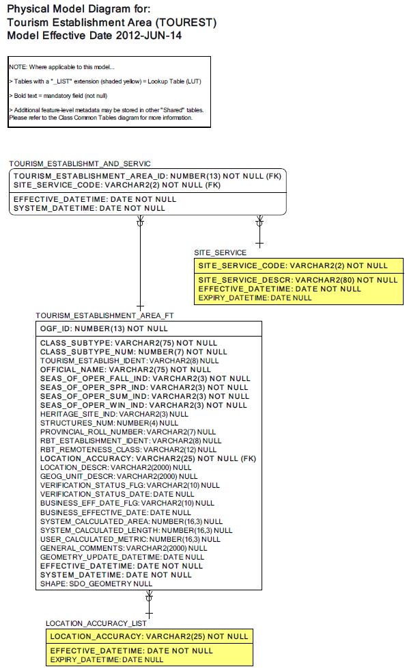
Data Class Change History

Data Class Name: Tourism Establishment Area
Data Class Short Name: TOUREST
Date  YYYY-MM-DD | Details of Change
2009-04-02 | Conversion of existing NRVIS data to new GUT values in NRVIS Tourism Establishment Area data class:  GUT Conversion:  - Main Base Lodge, Not Remote (#1135) becomes GUT: Main Base Lodge (#125)  - Main Base Lodge, Remote (#1136) becomes GUT: Main Base Lodge (#125)  - Outpost, Not Remote (#1182) becomes GUT: Outpost Camp (#126)  - Outpost, Remote (#1183) becomes GUT: Outpost Camp (#126)
2009-04-02 | GUTs Retired:  - Main Base Lodge, Not Remote (#1135)  - Main Base Lodge, Remote (#1136)  - Outpost, Not Remote (#1182)  - Outpost, Remote (#1183)
2008 | 2 new GUTS added to deal with Resource Based Tourism (RBT) district information requirements: Main Base Lodge and Outpost Camp. The existing Remote/Not Remote GUTS for these features will be converted to the new GUTS, then expired.
2008 | Column added: RBT Remoteness (to accomodate the classification formerly used by the soon-to-be expired GUTS).
1996 | New Data Class for NRVIS 1.0
Data Description
Please refer to the metadata record for the data description.

